Token Activation Instructions – Literatum Platform

Browse to http://journals.sagepub.com/
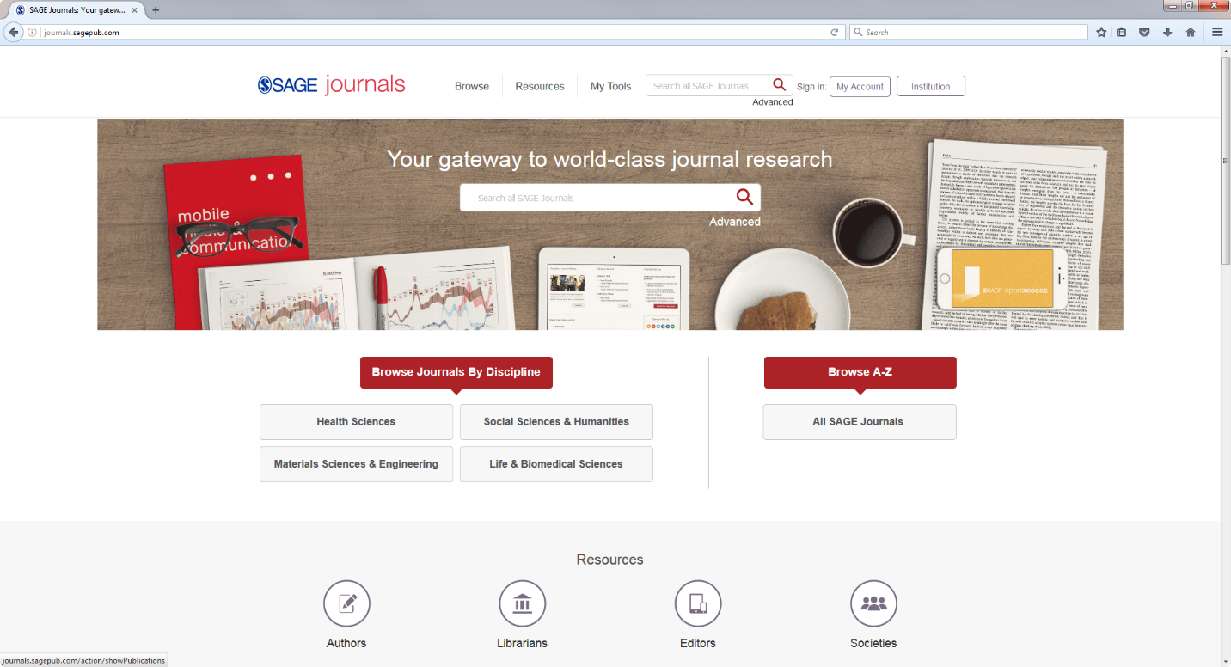
Click on “Societies”
Click on “activate your member subscription”
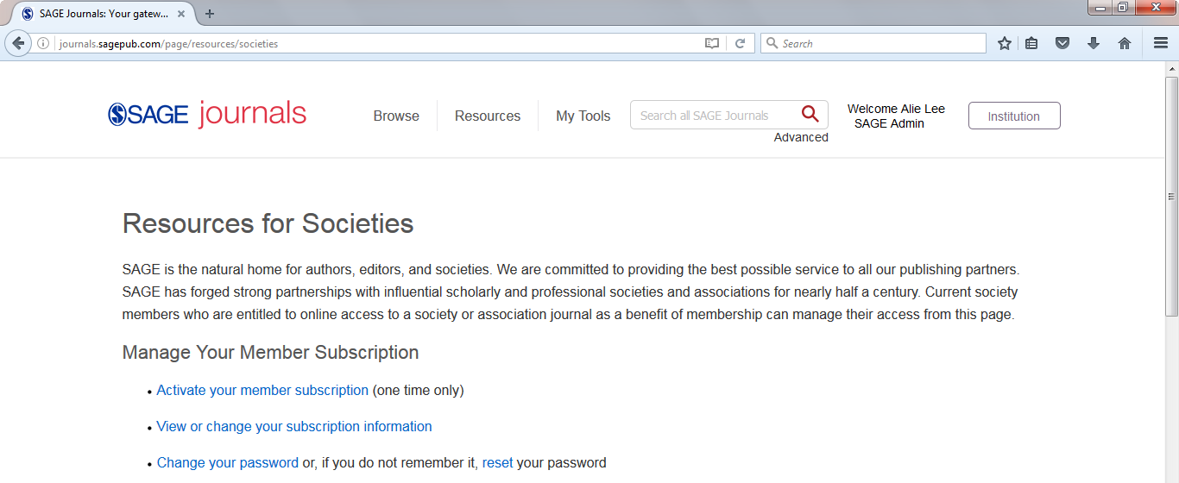

Now you need to register for an account, or sign-in to an existing one
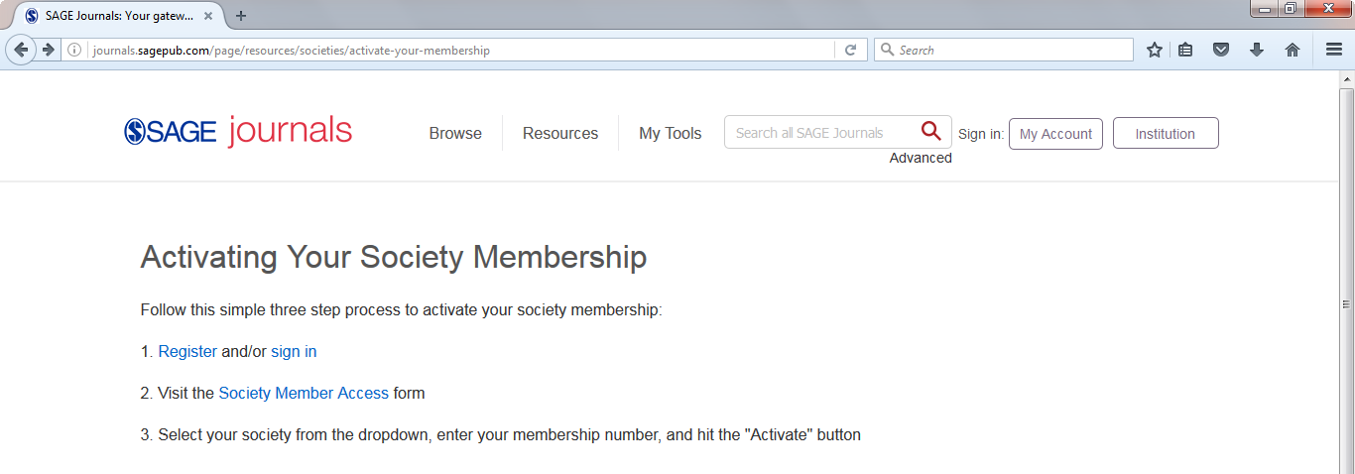

If you are already signed in, click “Visit the Society Member Access Form”
Otherwise sign in or register and then click on My Tools and select My Account
Click on Society Member Access
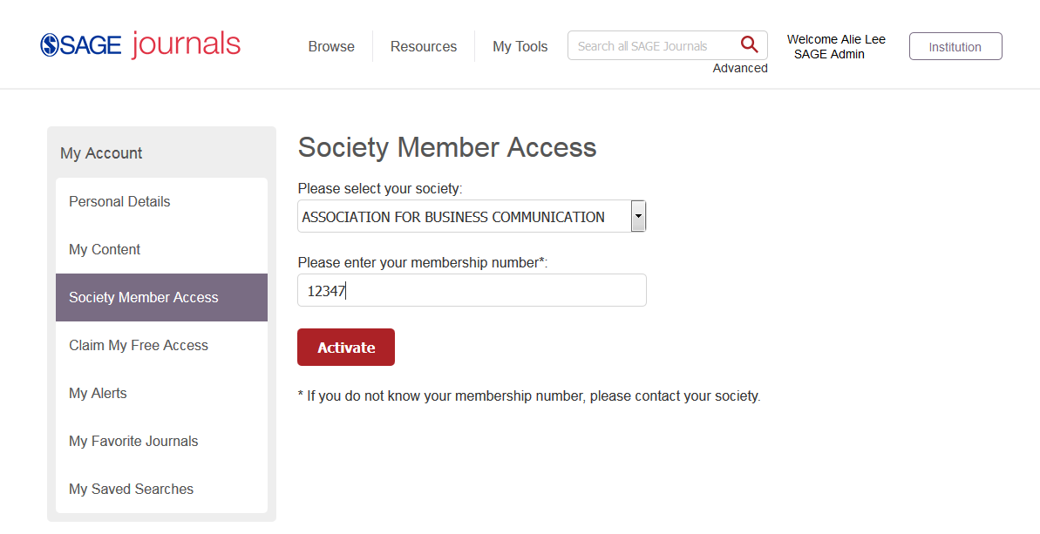
Select your society from the drop-down
Enter your Member ID (e.g. 12347)
Click ACTIVATE (you should receive a “success” message)
To check the content you have access to:
Click on My Content and the journals you currently have access to will be listed.
